Euler function

Group
A group G = <S, º > is a pair, where
- S is a finite or infinite set of elements;
- º is a binary operation (called the group operation) that together satisfy the four fundamental properties of closure, associativity, the identity property, and the inverse property.

1. Closure: If a and b are two elements in G, then a º b is also in G.
2. Associativity: The defined operation º is associative, i.e., for all a, b, c ∈ G we have: (a º b) º c = a º (b º c).
3. Identity: There is an identity element I (a.k.a. 1, E or e) such that I º a = a º I = a for every element a ∈ G.
4. Inverse: There must be an inverse (a.k.a. reciprocal) of each element. Therefore, for each element a of G, the set contains an element b = a⁻¹ such that
a º a⁻¹ = a⁻¹ º a = I

Let N be a set of positive integers. Then:
- <N, +> is not a group, there is no identity element.
- <N ∪ {0}, +> is not a group, identity = 0, but there is no inverse element.
Let Z be a set of integers. Then:
- <Z, +> is a group, identity = 0, 3⁻¹ = -3, -3⁻¹ = 3.
- <Z, *> is not a group, identity = 1, but there is no inverse element.
Let Q be a set of fractions. Then:
- < Q, *> is a group, identity = 1, 3⁻¹ = 1/3, 2/7⁻¹ = 7/2.
Let M be a set of matrices. Then:
- < M \ (0), *> is a group, identity = E, each matrix has an inverse. Matrix multiplication is associative, but not commutative.

Complete residue system
A subset S of the set of integers is called a complete residue system modulo n if
- no two elements of S are congruent modulo n;
- S contains n elements;
For example, a complete residue system modulo 5 is {3, 4, 5, 6, 7}, which is equivalent to {0, 1, 2, 3, 4}.

Z_{n} = {0, 1, 2, …, n – 1} is a complete residue system consisting of minimal nonnegative residues.

< Z_{n}, + _{mod n}> is a group. For example, Z₅ = {0, 1, 2, 3, 4}.
Closure: 3 + 4 = 2 because (3 + 4) mod 5 = 2.
Associativity: (3 + 4) + 2 = 3 + (4 + 2) = 4.
Identity: I = 0.
Inverse: 3⁻¹ = 2 because 3 + 2 = 0 (mod 5), 4⁻¹ = 1.

Reduced residue system
A subset Z_{n}* of the set of integers is called a reduced residue system modulo n if
- Each element in Z_{n}* is no more than n;
- Each element in Z_{n}* is coprime with n;
< Z_{n}*, * _{mod n}> is a group.
For example, Z₁₀* = {1, 3, 7, 9}, Z₁₂* = {1, 5, 7, 11}. Product of any numbers from the set modulo n belongs to the same set:
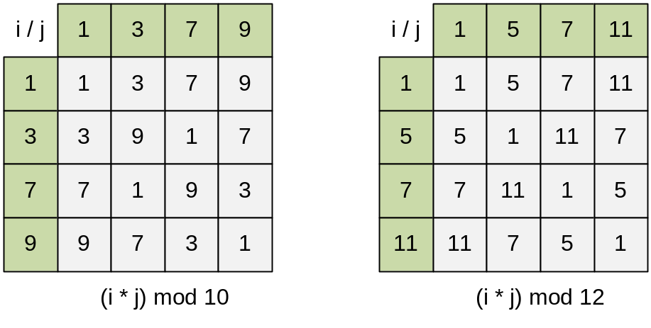
If p is prime, then Z_{p}* = {1, 2, 3, …, p – 1}. All positive integers less than p belong to Z_{p}* because they are coprime with p. For example, Z₇* = {1, 2, 3, 4, 5, 6}.

The cardinality of the set Z_{n}* equals to Euler function ϕ(n):
| Z_{n}* | = ϕ(n)

Below the properties of the Euler function are given:
- if p is prime, then ϕ(p) = p – 1 and ϕ(pª) = pª * (1 – 1/p) for any a.
- if m and n are coprime, then ϕ(m * n) = ϕ(m) * ϕ(n).
- if n = 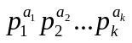, the Euler function is calculated using the next formula:
ϕ(n) = n * (1 – 1/p₁) * (1 – 1/p₂) * ... * (1 – 1/p_{k})

For example,
ϕ(20) = ϕ(2² * 5) = 20 * (1 – 1/2) * (1 – 1/5) = 20 * 1/2 * 4/5 = 8,
ϕ(12) = ϕ(2² * 3) = 12 * (1 – 1/2) * (1 – 1/3) = 12 * 1/2 * 2/3 = 4,
ϕ(10) = ϕ(2 * 5) = 10 * (1 – 1/2) * (1 – 1/5) = 10 * 1/2 * 4/5 = 4

Function euler finds the value of ϕ(n).

int euler(int n)
{

Initialize result with n.

int i, result = n;

Iterate over all prime divisors i of n.

for(i = 2; i * i <= n; i++)
{

If i is a prime divisor of n, calculate
result = result * (1 – 1 / i) = result – result / i

if (n % i == 0) result -= result / i;

Remove all divisors i from n.

while (n % i == 0) n /= i;
}

If n > 1, then initially n contained a prime divisor greater than 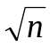. For example, number 10 = 2 * 5 contains prime divisor 5, greater than 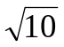. Take this divisor into account when calculating the result.

if (n > 1) result -= result / n;
return result;
}

E-OLYMP 339. Again irreducible The fraction m / n is called regular irreducible, if 0 < m < n and GCD(m, n) = 1. Find the number of regular irreducible fractions with denominator n.
► The number of regular irreducible fractions with denominator n equals to Euler's function ϕ(n). For n = 12 we have the following regular irreducible fractions:
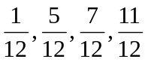

Consider the set of all regular fractions with the denominator 12:
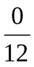, 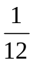, 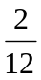, 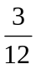, 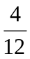, 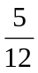, 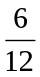, 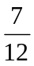, 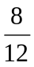, 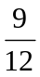, 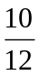, 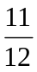
After simplifying, they will look like:
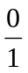, 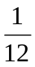, , , , , , , , , ,
Let's group the fractions by their denominators:
, , , , , , , , , , ,
Among the denominators, every divisor d of 12 occurs along with all ϕ(d) of its numerators. All denominators are divisors of 12. Hence
ϕ(1) + ϕ(2) + ϕ(3) + ϕ(4) + ϕ(6) + ϕ(12) = 12

If we start with a series of irreducible fractions 0 / m, 1 / m, …, (m – 1) / m, we can get the equality:
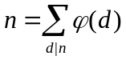

E-OLYMP 1563. Send a table Jimmy have to calculate a function f(x, y) where x and y are both integers in the range [1, n]. When he knows f(x, y), he can easily derive f(k*x, k*y), where k is any integer from it by applying some simple calculations involving f(x, y) and k.
Note that the function f is not symmetric, so f(x, y) can not be derived from f(y, x).
For example if n = 4, he only needs to know the answers for 11 out of the 16 possible input value combinations:
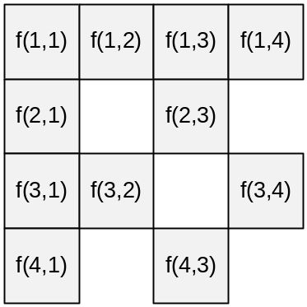
The other 5 can be derived from them:
- f(2, 2), f(3, 3) and f(4, 4) from f(1, 1);
- f(2, 4) from f(1, 2);
- f(4, 2) from f(2, 1);
For the given value of n find the minimum number of function values Jimmy needs to know to compute all n² values f(x, y).
► Let res(i) be the minimum required number of known values of f(x, y), where x, y ∈ {1, …, i}. Obviously, res(1) = 1, since for n = 1 it is enough to know f(1, 1).
Let the value of res(i) is known. For n = i + 1 we must find the values
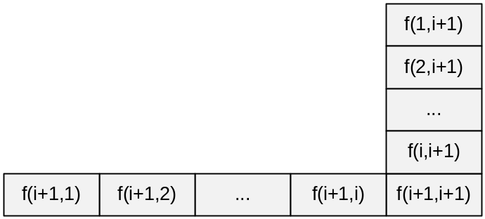
The values f(j, i + 1) and f(i + 1, j), j ∈ {1, …, i + 1} can be derived from the known values if GCD(j, i + 1) > 1, that is, if the numbers j and i + 1 are not coprime. Therefore, it is necessary to know all such f(j, i + 1) and f(i + 1, j), for which j and i + 1 are coprime. The number of such values is 2 * ϕ(i + 1), where ϕ is Euler's function. Thus
res(1) = 1,
res(i + 1) = res(i) + 2 * ϕ(i + 1), i > 1

Let’s find the values of res(i) for some values of i:
res(1) = 1,
res(2) = res(1) + 2 * ϕ(2) = 1 + 2 * 1 = 3,
res(3) = res(2) + 2 * ϕ(3) = 3 + 2 * 2 = 7,

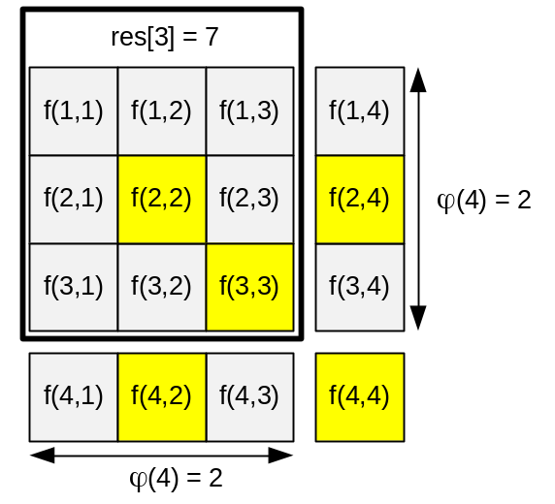
res(4) = res(3) + 2 * ϕ(4) = 7 + 2 * 2 = 11

Euler's theorem. If a and n are coprime, then a^{ϕ(n)} ≡ 1 (mod n).
| Z_{n}* | = ϕ(n)

Proof. Let Z_{n}* = { r₁, ..., r_{k}}, where k = ϕ(n). Then if we take any a ∈ Z_{n}* and find all possible products a * r_{i}, we get a set { r₁’ , ..., r_{k}’} that is just a permutation of { r₁, ..., r_{k}}. Consider the system of congruence equations:
ar₁ ≡ r₁’ (mod n),
ar₂ ≡ r₂’ (mod n),
… ,
ar_{k} ≡ r_{k}’ (mod n)
Multiply the equations:
a^{k} * r₁ * ... * r_{k} ≡ r₁’ * ... * r_{k}’ (mod n)
Since the products r₁ * ... * r_{k} and r₁’ * ... * r_{k}’ are equal and coprime modulo n, we’ll divide the equality by this product. We get
a^{k} ≡ 1 (mod n)
Since k = ϕ(n), we have
a^{ϕ(n)} ≡ 1 (mod n)

Fermat’s theorem (a special case of Euler's theorem).
If p is prime, a ∈ Z_{p}*, then
a^{p-1} ≡ 1 (mod p)

Corollary. If we multiply both sides of a^{p-1} ≡ 1 (mod p) by a, we obtain
a^{p} ≡ a (mod p)

Corollary. 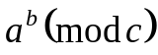 = 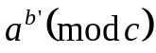, where b' = 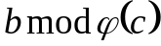.
Proof. Let b = 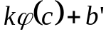.
Then = 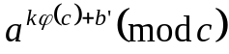 = 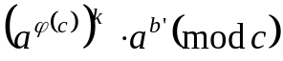 = .

Example. Find the value of 2¹⁰⁰ mod 17.
Since ϕ(17) = 16, 2¹⁰⁰ mod 17 = 2^{100 mod 16} mod 17 = 2⁴ mod 17 = 16.

Find the value of 2¹⁰⁰⁰ mod 100. Since
ϕ(100) = ϕ(2² * 5²) = 100 * (1 – 1/2) * (1 – 1/5) = 100 * 1/2 * 4/5 = 40,
2¹⁰⁰⁰ mod 100 = 2^{100 mod 40} mod 100 = 2²⁰ mod 100 = 1048576 mod 100 = 76.

Example. Let’s find an inverse for each element from Z₁₀* = {1, 3, 7, 9}. From the Euler theorem we have a^{ϕ(10)} ≡ 1 (mod 10) or a⁴ ≡ 1 (mod 10), a * a³ ≡ 1 (mod 10), so
a⁻¹ = a³ (mod 10)
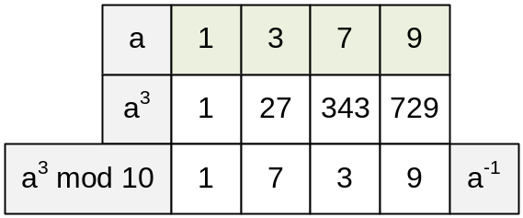
So 1⁻¹ = 1, 3⁻¹ = 7, 7⁻¹ = 3, 9⁻¹ = 9.

E-OLYMP 5213. Inverse Prime number n is given. The inverse number to i (1 ≤ i < n) is such number j that i * j = 1 (mod n). Its possible to prove that for each i exists only one inverse. For all possible values of i find the inverse numbers.
► Since the number n is prime, then by Fermat's theorem i^{n-1} mod n = 1 for every 1 ≤ i < n. This equality can be rewritten in the form (i * i^{n-2}) mod n = 1, whence the inverse of i equals to j = i^{n-2} mod n.
Let n = 5. Consider the table:
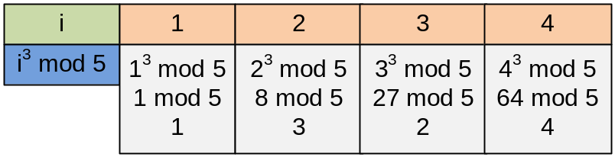

E-OLYMP 9606. Modular division Three positive integers a, b and n are given. Find the value of a / b mod n. You must fund such x that b * x = a mod n.
► Since number n is prime, then by Fermat's theorem b^{n-1} mod n = 1 for every 1 ≤ b < n. This equality can be rewritten in the form (b * b^{n-2}) mod n = 1, whence the inverse of b equals to y = b^{n-2} mod n.
Hence a / b mod n = a * b⁻¹ mod n = a * y mod n.

Consider the sample: compute 4 / 8 mod 13. To do this, solve the equation 8 * x = 4 mod 13, wherefrom x = (4 * 8⁻¹) mod 13.
Number 13 is prime, Fermat's theorem implies that 8¹² mod 13 = 1 or (8 * 8¹¹) mod 13 = 1. Therefore 8⁻¹ mod 13 = 8¹¹ mod 13 = 5.
Compute the answer: x = (4 * 8⁻¹) mod 13 = (4 * 5) mod 13 = 20 mod 13 = 7.

E-OLYMP 9627. a^b^c Find the value of
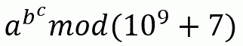
► By Fermat's little theorem a^{p – 1} = 1 (mod p), where p is prime. The number p = 10⁹ + 7 is prime. Hence, for example, it follows that a^{(p – 1) * l} = 1 (mod p) for any number l.
To evaluate the expression a^b^c first find k = b^c, then calculate a^k. However, the number b^c is large, we represent it in the form b^c = (p – 1) * l + s for some l and s < p – 1. Then
a^(b^c) mod p = a^{(p – 1) * l + s} mod p = (a^{(p – 1) * l} * a^{s}) mod p = a^{s} mod p
It's obvious that s = b^c mod (p – 1). Hence
a^(b^c) mod p = a^(b^c mod (p – 1)) mod p

Let’s calculate the value of 3^2^3 mod 7. Module 7 is chosen to be prime. The value of expression is
3^(2^3) mod 7 = 3⁸ mod 7 = 6561 mod 7 = (937 * 7 + 2) mod 7 = 2

Fermat's theorem implies that 3⁶ mod 7 = 1. Therefore, for any positive integer k
(3⁶ mod 7)^{k} = 3^{6k} mod 7 = 1
Since 2^3 = 2³ = 8, then 3⁸ mod 7 = 3^{6 * 1 + 2} mod 7 = 3² mod 7 = 9 mod 7 = 2

The original expression can also be evaluated as
3^(2^3) mod 7 = 3⁸ mod 7 = 3^{8 mod 6} mod 7 = 3² mod 7 = 9 mod 7 = 2

E-OLYMP 1083. Sequence In a sequence of numbers a₁, a₂, a₃, ... the first term is given, and the other terms are calculated using the formula:
a_{i} = (a_{i-1} * a_{i-1}) mod 10000
Find the n-th term of the sequence.
► Let us express the first terms of the sequence in terms of a₁:
- a₂ = a₁² mod 10000,
- a₃ = a₂² mod 10000 = a₁⁴ mod 10000,
- a₄ = a₃² mod 10000 = a₂⁴ mod 10000 = a₁⁸ mod 10000
The formula can be rewritten as a_{i} = a_{i-1}² mod 10000, whence it follows that to calculate a_{n}, the number a₁ should be raised to the power 2^{n–1}:
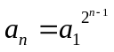
Considering that a^{b} mod n = a^{b mod ϕ(n)} mod n, to find the result res, the following calculations should be performed:
x = 2^{n–1} mod ϕ(10000) = 2^{n–1} mod 4000,
res = a₁^{x} mod 10000

E-OLYMP 7807. Happy sum It is known that the number is happy, if its decimal notation contains only fours and sevens. For example, the numbers 4, 7, 47, 7777 and 4744474 are happy.
Let S be the set of happy numbers, no less than a and no more than b:
S = {n : a ≤ n ≤ b, n is happy}
Calculate the remainder of dividing by 1234567891 the next sum:
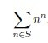
► The modulus p = 1234567891 is primt. So n^{p – 1} = 1 (mod p). We have
n^{n} (mod p) = (n mod p) (p – 1) + … + (p – 1) + (n mod (p – 1)) (mod p) =
(n mod p) ^{n mod (p – 1)} (mod p)
For example 23²³ (mod 5) = (23 mod 5) ⁴ ⁺ ⁴ ⁺ ⁴ ⁺ ⁴ ⁺ ⁴ ⁺ ³ (mod 5) = 3³ (mod 5), because 3⁴ (mod 5) = 1.
Let modPow(a, n) = a^{n} mod p. Since n ≤ 10¹⁸, then the arguments of modPow(n, n) wikk have the type long long and when multiplying we get overflow. From the above equality we have:
modPow(n, n) = modPow(n mod p, n mod (p – 1))
Now we can pass int arguments to the function modPow.

To generate happy numbers, it should be noted that if n is happy, then numbers 10*n + 4 and 10*n + 7 will be also happy.

Recursive generation of happy numbers.

void f(long long n)
{

As soon as the next generated number n becomes greater than b, we stop to generate the numbers.

if (n > b) return;

Sum up the values n^{n} only for those happy numbers n, for which a ≤ n ≤ b.

if (n >= a) res = (res + modPow(n % MOD, n % (MOD - 1))) % MOD;

In n is a happy number, then numbers 10*n + 4 and 10*n + 7 will be also happy.

f(n * 10 + 4);
f(n * 10 + 7);
}

Generate the happy numbers starting from 0. Calculate the required sum in the res variable.

f(0);

E-OLYMP 4742. Number of divisors The integer n is given. Find the number of its divisors, excluding divisors n and 1.
► Let d(n) be the number of divisors of n. Obviously, d(1) = 1.
Let p be prime integer. Then p has two divisors: 1 and p. Hence d(p) = 2.
Let n = p^{k} be the prime power. Then n has k + 1 divisors: 1, p, p², p³, …, p^{k}. So d(p^{k}) = k + 1.
Let n = p^{k}q^{l}. Consider two sets:
P ={1, p, p², p³, …, p^{k} } and Q ={1, q, q², q³, …, q^{l} }
Any divisor d of the number p^{k}q^{l} can be represented in the form x * y, where x ∈ P, y ∈ Q. Divisor x from P can be chosen in k + 1 ways, divisor y from Q can be chosen in l + 1 ways. Hence the divisor d = x * y can be constructed in (k + 1) * (l + 1) ways.

Decompose the number n into prime factors: n = 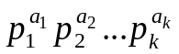. The number of divisors of n is
d(n) = (a₁ + 1) * (a₂ + 1) * … * (a_{k} + 1)

Factorize the number of n = 18:
18 = 2 * 3²
Therefore
d(18) = (1 + 1) * (2 + 1) = 2 * 3 = 6
Subtracting two divisors (1 and 18), we get the answer: 4 divisors.

Function CountDivisors factorize the number n and calculates the number of its divisors d(n). In the variable res, we count the number of divisors of the number n. In the for loop, when we meet the divisor i of n, in the variable c we calculate the degree with which i is included in the number n. That is, c is the maximum degree for which n is divisible by i^{c}.

int CountDivisors(int n)
{
int c, i, res = 1;
for(i = 2; i * i <= n; i++)
{
if (n % i == 0)
{
c = 0;
while(n % i == 0)
{
n /= i;
c++;
}
res *= (c + 1);
}
}
if (n > 1) res *= 2;
return res;
}

E-OLYMP 1564. Number theory For the given positive integer n find the number of integers m, such that 1 ≤ m ≤ n, GCD(m, n) ≠ 1 and GCD(m, n) ≠ m. GCD is an abbreviation for “greatest common divisor”.
► From the number n, we must subtract the number of coprime numbers with n, that equals to the Euler function ϕ(n) (if m and n are coprime, then GCD(m, n) = 1), and the number of its divisors (if m is a divisor of n, then GCD(m, n) = m). In this case, the number 1 will be simultaneously coprime with n and a divisor of n. Therefore, 1 should be added to the resulting difference.
If n = 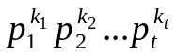 is a factorization of n, it has d(n) = (k₁ + 1) * (k₂ + 1) * … * (k_{t} + 1) divisors.
Thus, the number of required values of m for the given n equals to
n – ϕ(n) – d(n) + 1

Let n = 10. We have ϕ(10) = 4 coprime numbers with 10: 1, 3, 7, 9.
Number 10 has d(10) = d(2 * 5) = 2 * 2 = 4 divisors: 1, 2, 5, 10.
The number of integers m, such that 1 ≤ m ≤ 10, GCD(m, 10) ≠ 1 and GCD(m, 10) ≠ m is
10 – ϕ(10) – d(10) + 1 = 10 – 4 – 4 + 1 = 3

E-OLYMP 4107. Totient extreme Given the value of n, you will have to find the value of H. The meaning of H is given in the following code:

H = 0;
for (i = 1; i <= n; i++) {
for (j = 1; j <= n; j++) {
H = H + totient(i) * totient(j);
}
}

Totient or phi function, φ(n) is an arithmetic function that counts the number of positive integers less than or equal to n that are relatively prime to n. That is, if n is a positive integer, then φ(n) is the number of integers k in the range 1 ≤ k ≤ n for which GCD(n, k) = 1.
► Let us rewrite the sum H as follows:
φ(1) * φ(1) + φ(1) * φ(2) + … φ(1) * φ(n) +
φ(2) * φ(1) + φ(2) * φ(2) + … φ(2) * φ(n) +
. . .
φ(n) * φ(1) + φ(n) * φ(2) + … φ(n) * φ(n) =

φ(1) * (φ(1) + φ(2) + … φ(n)) +
φ(2) * (φ(1) + φ(2) + … φ(n)) +
. . .
φ(n) * (φ(1) + φ(2) + … φ(n)) =

= (φ(1) + φ(2) + … φ(n))²
Let's implement a sieve that will calculate all values of the Euler function from 1 to 10⁴ and put them into the array fi. Let's fill in the array of partial sums sum[i] = φ(1) + φ(2) + … φ(i). Next, for each input value of n, print sum[n] * sum[n].

Consider the arrays with values of Euler function fi and the array of partial sums sum:
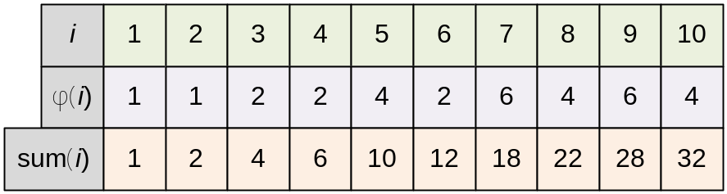

For n = 10 the answer is
(φ(1) + φ(2) + … φ(10))² = sum[10]² = 32² = 1024

Function FillEuler filles the array fi[i] with values of Euler function: fi[i] = φ(i) (1 ≤ i < MAX).

void FillEuler(void)
{
int i, j;

Initialize φ(i) = i.

for (i = 0; i < MAX; i++) fi[i] = i;
for (i = 2; i < MAX; i++)
if (fi[i] == i)

Number i is prime. Iterate through all values of j > i for which i is a prime divisor.

for (j = i; j < MAX; j += i)

If i is a prime divisor of j, then φ(j) = φ(j) * (1 – 1 / i) = φ(j) – φ(j) / i.

fi[j] -= fi[j] / i;
}

Consider an example. Initialize φ(i) = i:
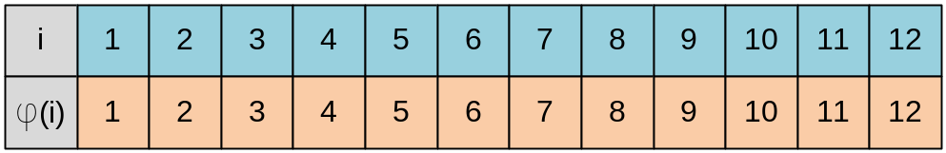
Start the for loop from i = 2. fi[2] = 2, so 2 is prime.
Start for j loop, j = 2, 4, 6, 8, 10, 12, recalculate fi[j] = fi[j] * (1 – 1 / 2) = fi[j] / 2.
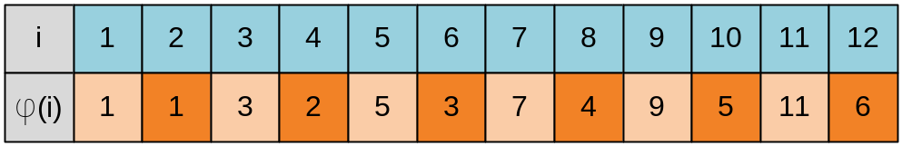

Next value of i = 3. fi[3] = 3, so 3 is prime.
Start for j loop, j = 3, 6, 9, 12, recalculate fi[j] = fi[j] * (1 – 1 / 3) = fi[j] * 2 / 3.
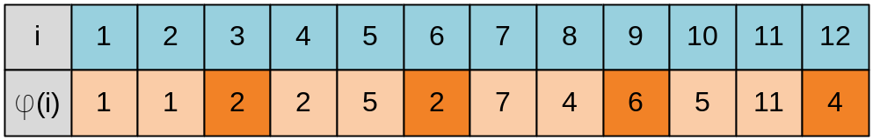

Next value of i for which fi[i] = i, is 5 (5 is prime).
Start for j loop, j = 5, 10, recalculate fi[j] = fi[j] * (1 – 1 / 5) = fi[j] * 4 / 5.
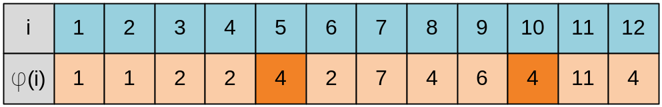

Next value of i for which fi[i] = i, is 7 (7 is prime).
Start for j loop, j = 7, recalculate fi[j] = fi[j] * (1 – 1 / 7) = fi[j] * 6 / 7.
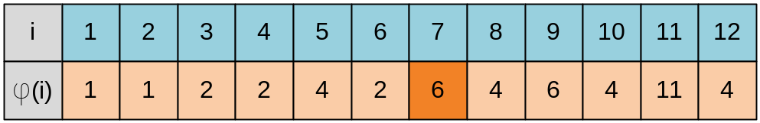

Next value of i for which fi[i] = i, is 11 (11 is prime).
Start for j loop, j = 11, recalculate fi[j] = fi[j] * (1 – 1 / 11) = fi[j] * 10 / 11.
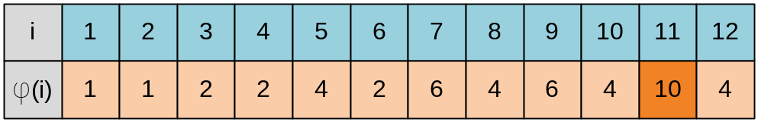

E-OLYMP 1128. Longge’s problem Longge is good at mathematics and he likes to think about hard mathematical problems which will be solved by some graceful algorithms. Now a problem comes:
Given an integer n (1 < n < 2³¹), you are to calculate ∑gcd(i, n) for all 1 ≤ i ≤ n.
“Oh, I know, I know!” Longge shouts! But do you know? Please solve it.
► Theorem. If the function f(n) is multiplicative, then the summation function S_{f}(n) = 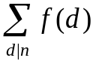 is also multiplicative.
Proof. Let x, y ∈ N, where x and y are coprime. Let x₁, x₂, …, x_{k} be all divisors of x. Let y₁, y₂, …, y_{m} be all divisors of y. Then GCD(x_{i}, y_{j}) = 1, and all possible products x_{i}y_{j} give all divisors of xy. Then
S_{f} (x) * S_{f} (y) = 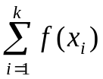 * 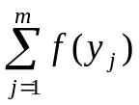 = 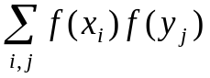 = 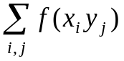 = S_{f} (xy)

Corollary. Consider the function f(n) = GCD(n, c), where c is a constant. If x and y are coprime, then f(x * y) = GCD(x * y, c) = GCD(x, c) * GCD(y, c) = f(x) * f(y). Therefore the function f(n) = GCD(n, c) is multiplicative.
Let g(n) = 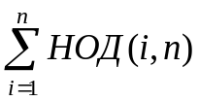. Then
g(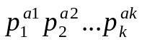) = g(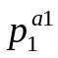) * g(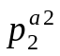) * … * g(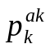)

Theorem. For any prime p and positive integer a holds the relation:
g(pª) = (a + 1)pª – ap^{a–1}
► For а = 1 we have:
g(p) = GCD(1, p) + GCD(2, p) + … + GCD(p, p) = (p – 1) + p = 2p – 1

Similarly for а = 2:
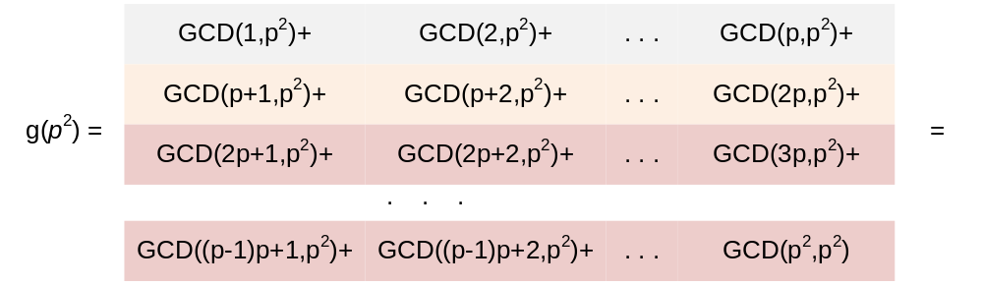

= (1 + 1 + … + 1 + p) +
(1 + 1 + … + 1 + p) +
…
(1 + 1 + … + 1 + p²) =

= (p – 1 + p) * (p – 1) + (p – 1 + p²) =
(2p – 1) * (p – 1) + (p² + p – 1) =
2p² – 2p – p + 1 + (p² + p – 1) =
= 3p² – 2p

Lemma. If d is a divisor of n, then there are exactly 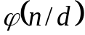 numbers i such that GCD(i, n) = d.
► Obviously i must be divisible by d, let i = dj. Then
GCD(i, n) = GCD(dj, n) = d * GCD(j, n / d)
If the last expression is equal to d, then GCD(j, n / d) = 1. The number of such j that GCD(j, n / d) = 1 is .

Example. The number of such i that GCD(i, 24) = 3 is 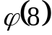 = 4.
GCD(j, 8) = 1 for j ∈ {1, 3, 5, 7}, therefore GCD(i, 24) = 3 for i ∈ {3, 9, 15, 21} (we have i = 3j).

Theorem.
g(n) = 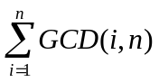 = 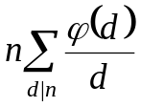
► According to the above lemma, the number of pairs (i, n) for which GCD(i, n) = e, is exactly 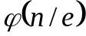. Replacing n / e = d, we get:
g(n) = 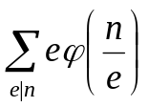 = 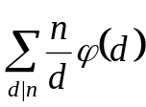 =

Example. Let n = 6.
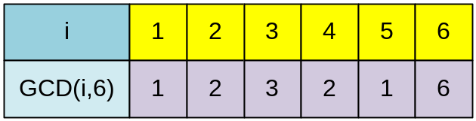
Then g(6) = 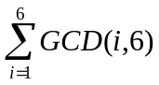 =
= GCD(1, 6) + GCD(2, 6) + GCD(3, 6) + GCD(4, 6) + GCD(5, 6) + GCD(6, 6) =
= 1 + 2 + 3 + 2 + 1 + 6 = 15
In the same time g(6) = g(2) * g(3) =
(GCD(1, 2) + GCD(2, 2)) * (GCD(1, 3) + GCD(2, 3) + GCD(3, 3)) =
(1 + 2) * (1 + 1 + 3) = 3 * 5 = 15

Compute g(6) using the formula g(n) = :
g(6) =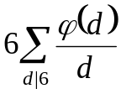 = 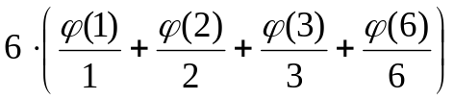 =
= 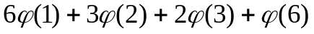 = 6 + 3 + 4 + 2 = 15

Let’s calculate g(6) based on the multiplicativity of the function f(x) = GCD(x, n):
g(6) = g(2) * g(3) = (2*2 – 1) * (2*3 – 1) = 3 * 5 = 15

Example. Let n = 12. Then g(12) = 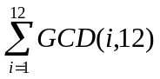 =
1 + 2 + 3 + 4 + 1 + 6 + 1 + 4 + 3 + 2 + 1 + 12 = 40
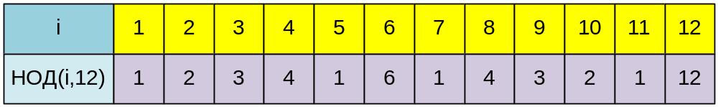

In the same time g(12) = g(4) * g(3) =
(GCD(1, 4) + GCD(2, 4) + GCD(3, 4) + GCD(4, 4)) *
* (GCD(1, 3) + GCD(2, 3) + GCD(3, 3)) =
(1 + 2 + 1 + 4) * (1 + 1 + 3) = 8 * 5 = 40

Compute g(12) using the formula g(n) = :
g(12) =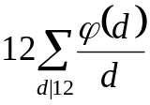 = 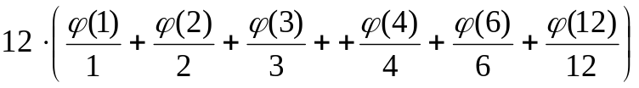 =
= =
= 12 + 6 + 8 + 6 + 4 + 4 = 40

The divisors of 12 are: 1, 2, 3, 4, 6, 12. The number of i such that GCD(i, 12) = d equals to 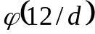. For example GCD(i, 12) = 3 holds for 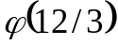 = 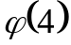 = 2 different i, namely for i = 3, 9.

Let’s calculate g(12) based on the multiplicativity of the function f(x) = GCD(x, n):
g(12) = g(2²) * g(3) = (3 * 2² – 2 * 2) * (2*3 – 1) = 8 * 5 = 40

Function euler computes the Euler function.

long long euler(long long n)
{
long long i, result = n;
for (i = 2; i * i <= n;i++)
{
if (n % i == 0) result -= result / i;
while (n % i == 0) n /= i;
}
if (n > 1) result -= result / n;
return result;
}

The main part of the program. Read value of n. Compute the value g(n) by the formula . Search for all divisors of n among the numbers from 1 to 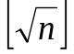. If i is a divisor of n, then n / i will be also the divisor of n. Therefore, for each found divisor i ≤ we must add to result res the value 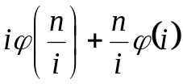. If n is a full square, i = sq = , then 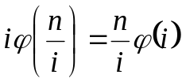 and two identical terms will be added to the res sum. Therefore we’ll subtract one of them from res during the initialization of the variable.

while(scanf("%lld",&n) == 1)
{
sq = (long long)sqrt(1.0*n);
res = (sq * sq == n) ? -sq * euler(sq) : 0;
for(i = 1; i <= sq; i++)
if(n % i == 0) res = res + i * euler(n/i) + (n / i) * euler(i);
printf("%lld\n",res);
}

E-OLYMP 1129. GCD Extreme II For a given number n calculate the value of G, where
G = 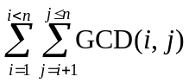
Here GCD(i, j) means the greatest common divisor of integers i and j.
For those who have trouble understanding summation notation, the meaning of G is given in the following code:
G = 0;
for(i = 1; i < n;i++)
for(j = i + 1 ;j <= n; j++)
{
G += GCD(i,j);
}
► Let d[k] = 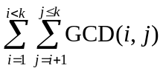.
For example d[2] = 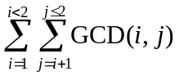 = 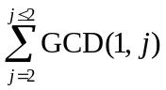 = GCD(1, 2) = 1.
You can see that
d[k] = = 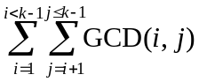 + 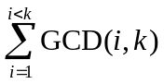 = d[k – 1] +

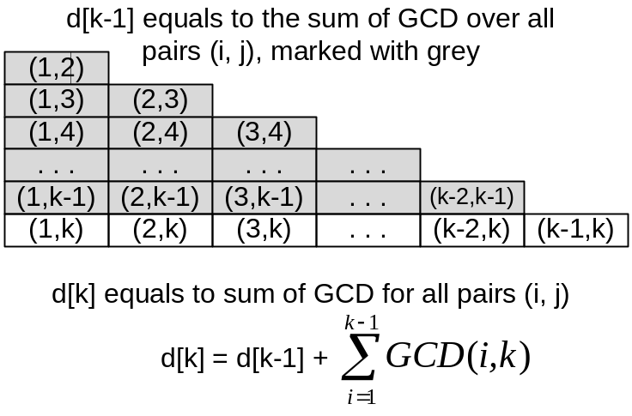
It remains to show how to calculate the value of faster than usual summation.

Lema. Let n is divisible by d and GCD(x, n) = d. Then x = dk for some positive integer k. From the relation GCD(dk, n) = d it follows that 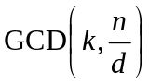 = 1.
Theorem. Let f(n) = 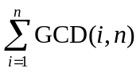. Then f(n) = 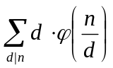 for all divisors d of number n. 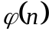 indicates here the Euler function.
Proof. The number of such i, for which GCD(i, n) = 1, equals to . The number of such i (i ≤ n), for which GCD(i, n) = d (d is a divisor of n, i = dk), equals to the number of such k (k ≤ 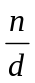), for which = 1 or 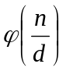. The value of GCD(i, n) can be only the divisors of n. To find the value f(n) it remains to sum the values 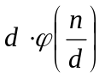 over all divisors d of n.

Example. Consider the direct calculation: f(6) = 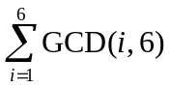 = GCD(1, 6) + GCD(2, 6) + GCD(3, 6) + GCD(4, 6) + GCD(5, 6) + GCD(6, 6) = 1 + 2 + 3 + 2 + 1 + 6 = 15.
Consider the calculation using the formula: f(6) = 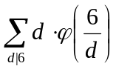 =
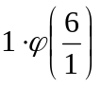 + 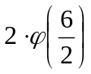 + 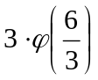 + 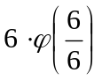 =
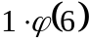 + 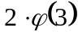 + 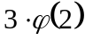 + 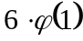 =
2 + 4 + 3 + 6 = 15
In the first and in the second case 15 is the sum of two units (), two doules (), one triple () and one sextuple ().

Declare the arrays. fi[i] stores the value of the Euler function ϕ(i).

#define MAX 4000010
long long d[MAX], fi[MAX];

The function FillEuler fills the array fi so that fi[i] = ϕ(i), i < MAX.

void FillEuler(void)
{

Initially set the value of fi[i] equal to i.

for(i = 2; i < MAX; i++) fi[i] = i;

Each even number i has a prime divisor p = 2. To speed up the function working time, process it separately. For each even number i set fi[i] = fi[i] * (1 – 1 / 2) = fi[i] / 2.

for(i = 2; i < MAX; i+=2) fi[i] /= 2;

Enumerate all the possible odd divisors i = 3, 5, 7, … .

for(i = 3; i < MAX; i+=2)
if(fi[i] == i)

If fi[i] = i, then the number i is prime. The number i is a prime divisor for any j, represented in the form k * i for any positive integer k.

for(j = i; j < MAX; j += i)

If i is a prime divisor of j, then set fi(j) = fi(j) * (1 – 1/i).

fi[j] -= fi[j]/i;
}

Before calling the function f the values d[i] already contain ϕ(i). The body of the function f adds to d[j] the values so that when the function finishes its work, the value d[j] contains 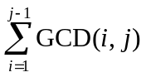 according to the formula given in the theorem.

void f(void)
{
int i, SQRT_MAX = sqrt(1.0*MAX);
for(i = 2; i <= SQRT_MAX; i++)
{
d[i*i] += i * fi[i];

The number i is a divisor of j. So we need to add to d[j] the value of 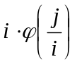. Since the number j has also a divisor j / i, add to d[j] the value of 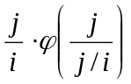 = 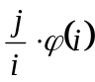. If i² = j, add to d[j] not two terms, but only one = 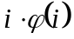.

// for(j = i * i + i; j < MAX; j += i)
// d[j] += i * fi[j / i] + j / i * fi[i];

We can avoid integer division in implementation. To do this note, that since the value of the variable j is incremented each time by i, then the value j / i will be increase by one in a loop. Set initially k = j / i = (i * i + i) / i = i + 1 and then increase k by 1 in each iteration.

for(j = i * i + i, k = i + 1; j < MAX; j += i, k++)
d[j] += i * fi[k] + k * fi[i];

}

Its sufficiently to continue the loop by i till 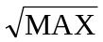, because if i is a divisor of j and i > , then considering the fact that j / i < we can state that the divisor i of the number j was taken in account when we considered the divider j / i.

}

The main part of the program. Initialize the arrays. Let d[i] = ϕ(i).

memset(d,0,sizeof(d));
FillEuler();
memcpy(d,fi,sizeof(fi));

i | 1 | 2 | 3 | 4 | 5 | 6 | 7 | 8 | 9 | 10
d[i] | 0 | 1 | 2 | 2 | 4 | 2 | 6 | 4 | 6 | 4

f();

i | 1 | 2 | 3 | 4 | 5 | 6 | 7 | 8 | 9 | 10
d[i] | 0 | 1 | 2 | 4 | 4 | 9 | 6 | 12 | 12 | 17

for(i = 3; i < MAX; i++)
d[i] += d[i-1];

i | 1 | 2 | 3 | 4 | 5 | 6 | 7 | 8 | 9 | 10
d[i] | 0 | 1 | 3 | 7 | 11 | 20 | 26 | 38 | 50 | 67

while(scanf("%lld",&n),n)
printf("%lld\n",d[n]);

E-OLYMP 5141. LCM sum Given n, calculate the sum LCM(1, n) + LCM(2, n) + … + LCM(n, n), where LCM(i, n) denotes the Least Common Multiple of the integers i and n.
► Let S = 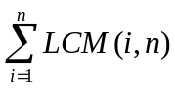 = 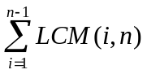 + LCM(n, n) = 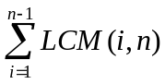 + n, wherefrom
S – n = LCM(1, n) + LCM(2, n) + . . . + LCM(n – 1, n)
Rearrange the terms in the right side in reverse order and write the equality in the form
S – n = LCM(n – 1, n) + . . . + LCM(2, n) + LCM(1, n)
Let's add two equalities:
2(S – n) = (LCM(1, n) + LCM(n – 1, n)) + . . . + (LCM(n – 1, n) + LCM(1, n))

Consider the expression in parentheses:
LCM(i, n) + LCM(n – i, n) = 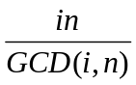 + 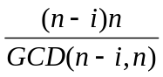
Note that the denominators of the last two terms are equal: GCD(i, n) = GCD(n – i, n), hence
+ = 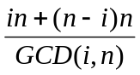 =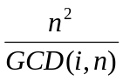
So
2(S – n) = 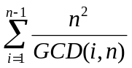 = 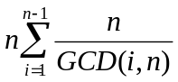

GCD(i, n) = d can take only the values of divisors of the number n, while the number of i for which the specified equality holds is φ (n / d). Hence
2(S – n) = = 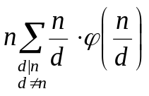 = 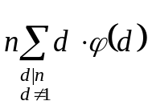 = 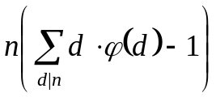

The second equality is true because if d is a divisor of n, then n / d is also a divisor of n. Moreover, if d ≠ n, then n / d ≠ 1. The last equality is valid, since the summand 1 * φ (1) = 1 is included in the sum. It remains to extract the value S from the equation:
2(S – n) = ,
2S – 2n = 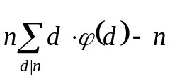,
S = 